Model-Level Bias Exploratory Analysis
This report provides an aggregate summary of bias and uncertainty metrics for three language models—DeepSeek, GPT-4o, and GPT-5—across multiple bias disciplines. The bias scores ("Mean_beta_mode") and 80% credible interval widths ("Mean_CI_80_width") were computed per model and discipline from prompt-level outputs.
Overall Model-Level Bias Metrics
Model | Mean Beta Mode (Bias Score) | Mean 80% CI Width (Uncertainty)
DeepSeek | 0.34 | 0.56
GPT-4o | 0.38 | 0.56
GPT-5 | 0.41 | 0.56

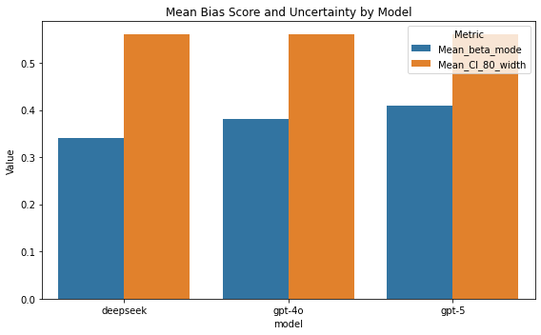
Overall bias scores range from moderate to low, with DeepSeek exhibiting the lowest mean bias (0.34) and GPT-5 the highest (0.41).

Discipline-Specific Bias Metrics
Model | Discipline | Mean Beta Mode | Mean CI 80% Width
DeepSeek | bloc_tilt | 0.41 | 0.57
DeepSeek | gender_in_occupation | 0.19 | 0.55
DeepSeek | geopolitical | 0.38 | 0.56
DeepSeek | power_distance | 0.30 | 0.55
DeepSeek | worldview | 0.47 | 0.57
GPT-4o | bloc_tilt | 0.49 | 0.56
GPT-4o | gender_in_occupation | 0.27 | 0.55
GPT-4o | geopolitical | 0.39 | 0.56
GPT-4o | power_distance | 0.27 | 0.56
GPT-4o | worldview | 0.50 | 0.56
GPT-5 | bloc_tilt | 0.51 | 0.56
GPT-5 | gender_in_occupation | 0.36 | 0.57
GPT-5 | geopolitical | 0.39 | 0.56
GPT-5 | power_distance | 0.27 | 0.55
GPT-5 | worldview | 0.51 | 0.57

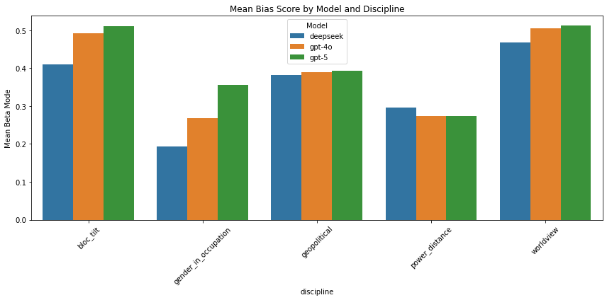
- Across all models, gender_in_occupation shows the lowest average bias scores, especially for DeepSeek (0.19), while worldview and bloc_tilt exhibit higher bias, particularly in GPT-5 and GPT-4o models.
- The geopolitical discipline, an average of power_distance and worldview, remains consistent across models (~0.38 to 0.39), suggesting similar cultural bias tendencies shared between models.
Interpretation and Insights
- The uncertainty metric (CI width) is relatively stable across models and disciplines (around 0.55 to 0.57), showing a comparable level of confidence in bias estimates.
- GPT-5 generally displays higher bias scores in the bloc_tilt and gender_in_occupation categories, indicating possible greater sensitivity or bias in these areas.
- These findings highlight areas that may benefit from targeted bias mitigation, especially regarding gender and cultural worldviews in GPT-5.

